JOINING FORCES FOR CHILDREN
RECOMMENDED BOOK TITLES
5 Ways to Show My Child I Love Them – Books with the Same Theme:
Hair Love by Matthew A. Cherry 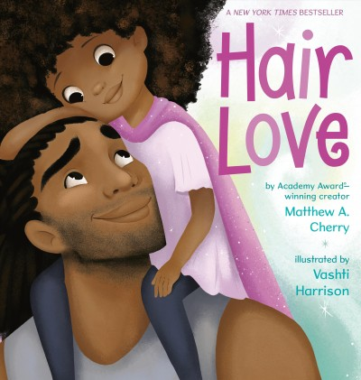
Plenty of Hugs by Fran Manushkin 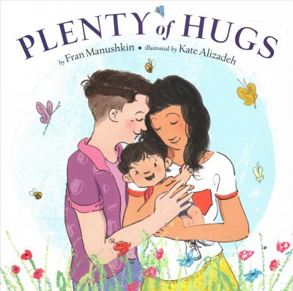
The I Love You Book by Todd Parr 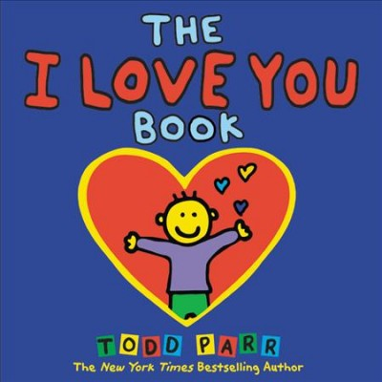
Huggy Kissy by Leslie Patricelli 
(baby/toddler)
Kiss by Kiss by Richard Van Camp 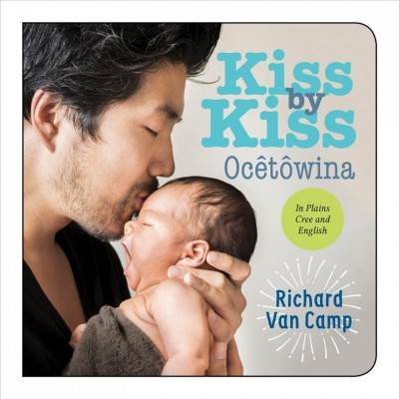
(baby/toddler)

5 Ways to Encourage My Child – Books with the Same Theme:

Show Me Happy by Kathryn Madeline Allen 
(baby/toddler)

I Will Be Fierce by Bea Birdsong 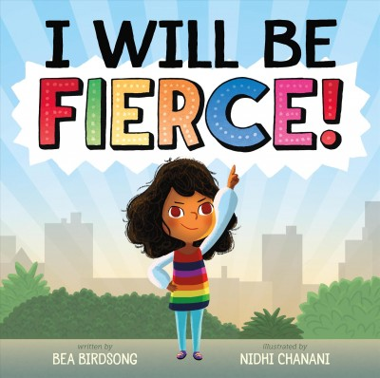
You Are Ready!: The World is Waiting by Eric Carle 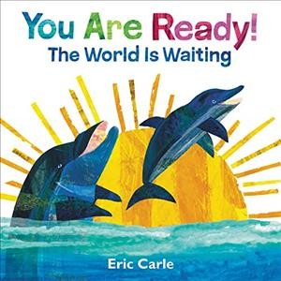
(baby/toddler)
Be Kind by Pat Zietlow Miller 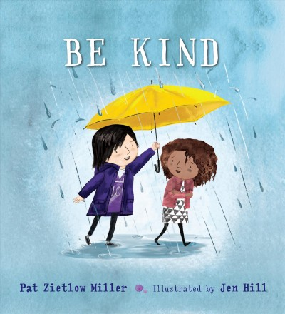
Be You! by Peter H. Reynolds 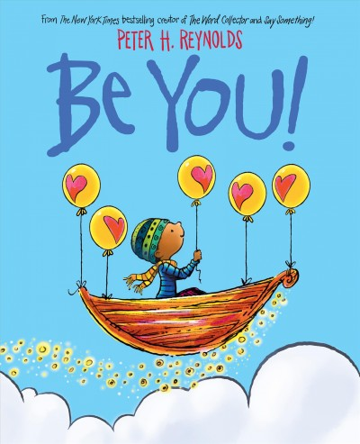
5 Ways to Help My Child Feel Safe – Books with the Same Theme:
Please Play Safe! Penguin’s Guide to Playground Safety by Margery Cuyler 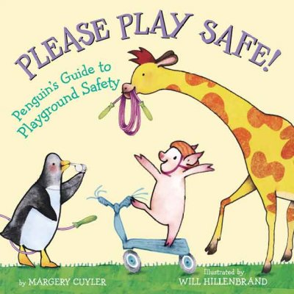
Kiss Baby’s Boo-Boo by Karen Katz 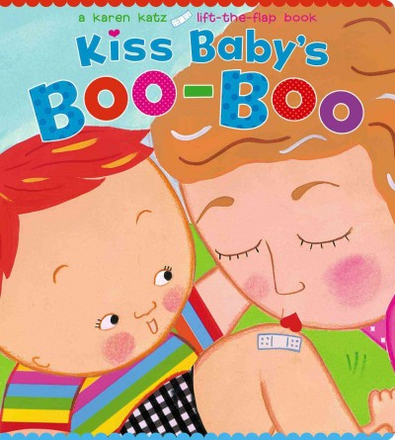
(baby/toddler)
Miles is the Boss of His Body by Samantha Kurtzman-Counter 
Fireboy to the Rescue!: A Fire Safety Book by Edward Miller 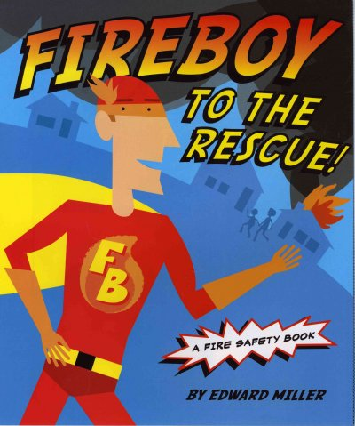
How Do Dinosaurs Stay Safe? by Jane Yolen 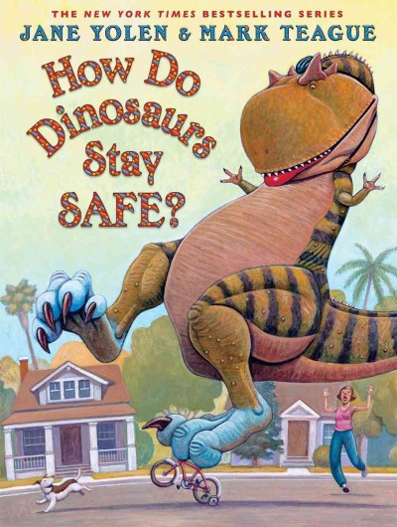

5 Ways to Spend Quality Time with My Child – Books with the Same Theme:

My Mama is a Mechanic by Doug Cenko 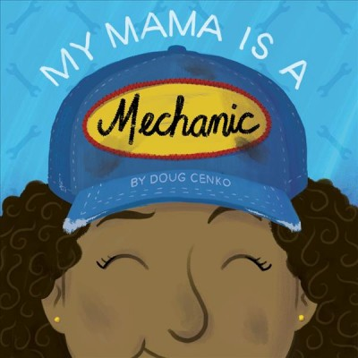
Lola Loves Stories by Anna McQuinn 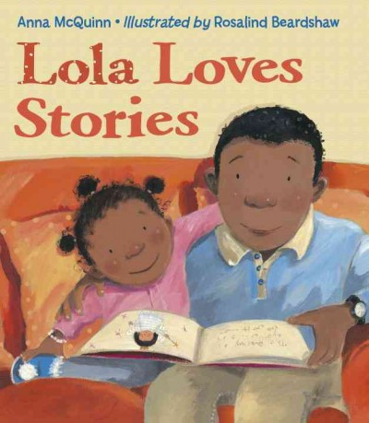

Saturday by Oge Mora 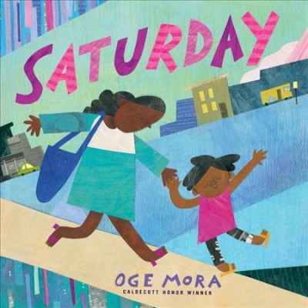
My Dad is the Best Playground by Luciana Navarro Powell 
(baby/toddler)
Pete’s a Pizza by William Steig 

5 Ways to Help My Child Be Creative – Books with the Same Theme:
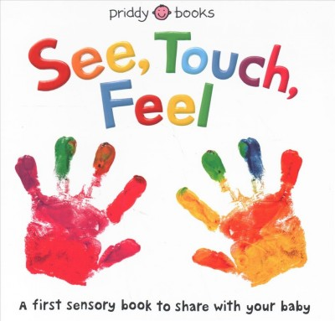
See, Touch, Feel: A First Sensory Book to Share with Your Baby by Ellie Boultwood
(baby/toddler)

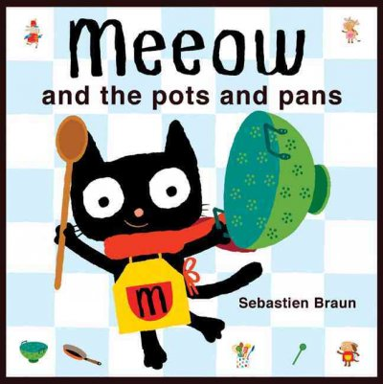
Meeow and the Pots and Pans by Sebastien Braun (baby/toddler)

Faster! Faster! by Leslie Patricelli 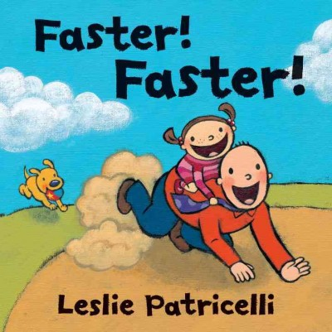

Play with Your Plate!: A Mix-and-Match Play Book by Judith Russell 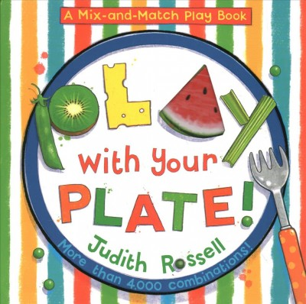

Mix It Up! by Hervé Tullet 